Lab Manual # 10
OBJECTIVE: To understand how a latch works to hold the data and set and reset states.
NOTE: Properly label the inputs and outputs in circuit diagrams & in timing diagrams

Lab Task 1:
Implement the combinational circuit of S'R' Latch on logic works using NAND gates and make the truth table.
Show the timing diagram also on logic works.

Lab Task 2:
Implement the combinational circuit of SR Latch on logic works using NOR gates and make the truth table.
Show the timing diagram also on logic works.
Timing Diagram:
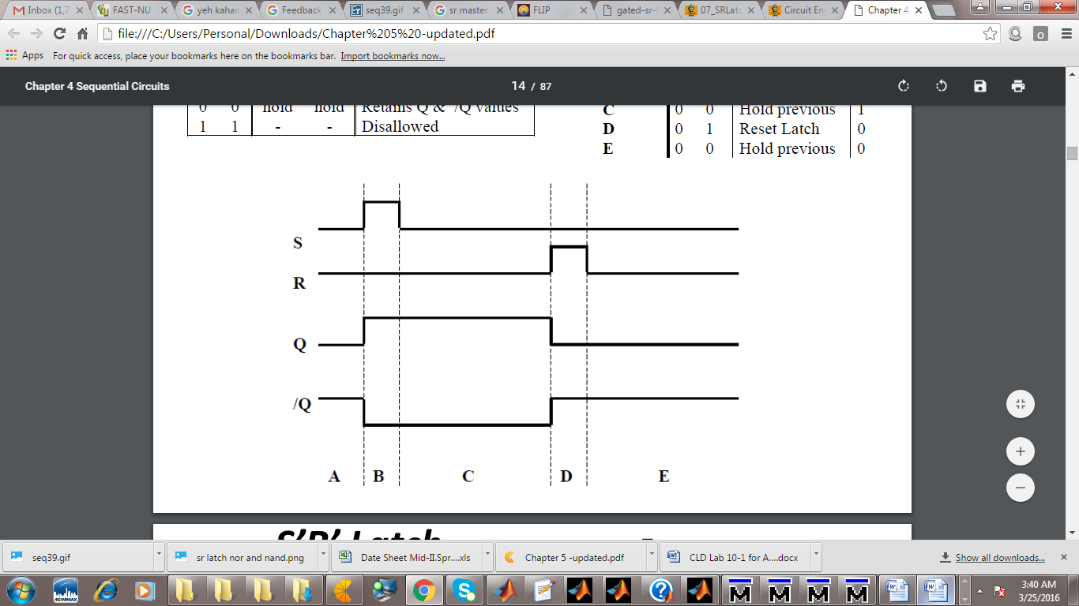

Lab Task 3:
Implement the combinational circuit of S'R' Latch with Control input on logic works and make the truth table.
Show the timing diagram also on logic works.
Timing Diagram:
